**Microprocessor Lab  
Lab Experiment No. 3**

Name: Ninad Rao Roll No. 53

**Aim**: Implementation of Multiplexer and Demultiplexer.

**Multiplexers**: Multiplexer is a combinational circuit that has a maximum of 2n data inputs, ‘n’ selection lines and single output line. One of these data inputs will be connected to the output based on the values of selection lines. Since there are ‘n’ selection lines, there will be 2n possible combinations of zeros and ones. So, each combination will select only one data input. Multiplexer is also called a Mux.

**2:1 Multiplexer**: A 2-to-1 multiplexer consists of two inputs D0 and D1, one select input S and one output Y. Depending on the select signal, the output is connected to either of the inputs. Since there are two input signals only two ways are possible to connect the inputs to the outputs, so one select is needed to do these operations.

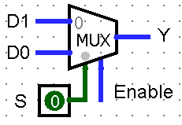

If the select line is low, then the output will be switched to D0 input, whereas if the select line is high, then the output will be switched to D1 input. The figure above shows the block diagram of a 2-to-1 multiplexer which connects two 1-bit inputs to a common destination.

**4:1 Multiplexer**: A 4-to-1 multiplexer consists of four data input lines as D0 to D3, two select lines as S0 and S1 and a single output line Y. The select lines S1 and S2 select one of the four input lines to connect the output line. The particular input combination on select lines selects one of input (D0 through D3) to the output.

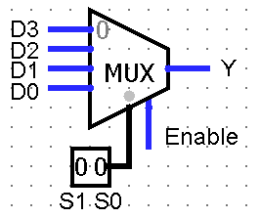

If the select line 0 and 1 is low, then the output will be switched to D0 input, if the select line 0 is high and 1 is low, then the output will be switched to D1 input, if the select line 0 is low and 1 is high, then the output will be switched to D2 input and if the select line 0 and 1 is high, then the output will be switched to D3 input. The figure above shows the block diagram of a 4-to-1 multiplexer which connects two 2-bit inputs to a common destination.

**8:1 Multiplexer**: An 8-to-1 multiplexer consists of eight data inputs D0 through D7, three input select lines S2 through S0 and a single output line Y. Depending on the select lines combinations, the multiplexer decodes the inputs.

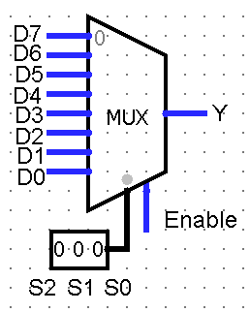

The above figure shows the block diagram of an 8-to-1 multiplexer with input that enables or disables the multiplexer. Since the number data bits given to the MUX are eight then 3 bits (23=8) are needed to select one of the eight data bits.

**Circuit Diagram**:

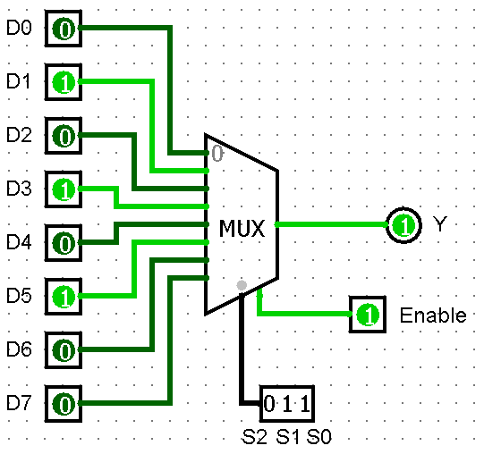 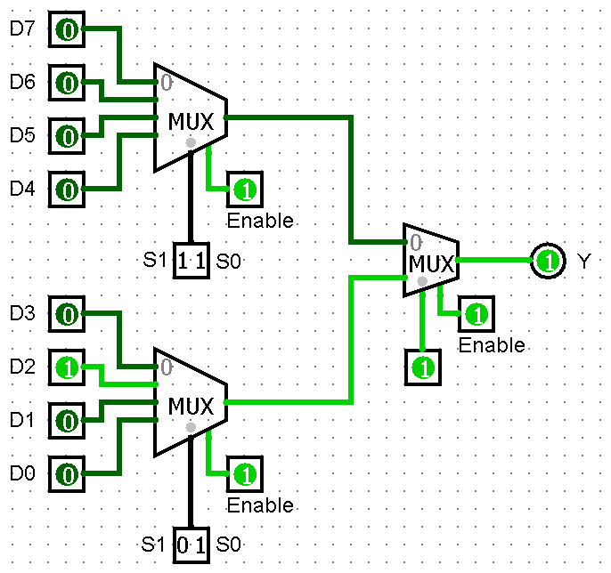

Above circuit diagrams are of 8:1 multiplexers using normal 8:1 MUX and two 4:1 MUXs with a 2:1 MUX respectively.

**Truth Table**:

|  |  |  |  |
| --- | --- | --- | --- |
| **S2** | **S1** | **S0** | **Y** |
| 0 | 0 | 0 | D0 |
| 0 | 0 | 1 | D1 |
| 0 | 1 | 0 | D2 |
| 0 | 1 | 1 | D3 |
| 1 | 0 | 0 | D4 |
| 1 | 0 | 1 | D5 |
| 1 | 1 | 0 | D6 |
| 1 | 1 | 1 | D7 |

**10:1 Multiplexer**: A 10-to-1 multiplexer consists of ten data inputs D0 through D9, four input select lines S3 through S0 and a single output line Y. Depending on the select lines combinations, the multiplexer decodes the inputs. The particular input combination on select lines selects one of input (D0 through D3) to the output.

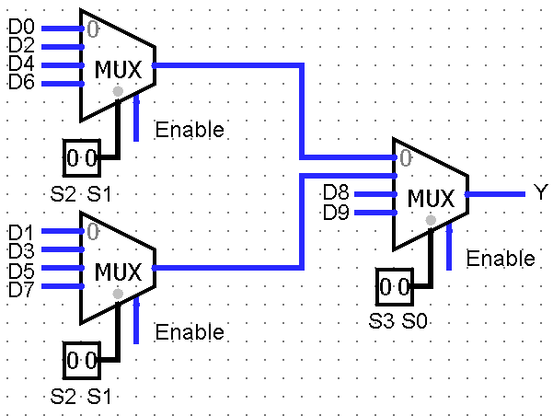

The above figure shows the block diagram of a 10-to-1 multiplexer using three 4-to-1 multiplexers with input that enables or disables the multiplexer.

**16:1 Multiplexer**: A 16-to-1 multiplexer consists of sixteen data inputs D0 through D15, four input select lines S3 through S0 and a single output line Y. Depending on the select lines combinations, the multiplexer decodes the inputs. The particular input combination on select lines selects one of input (D0 through D3) to the output.

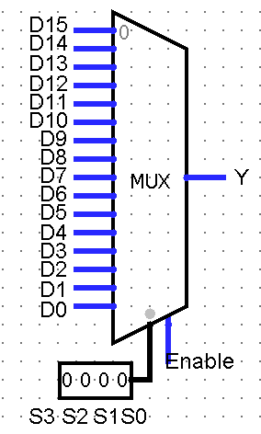

The below figure shows the block diagram of a 16-to-1 multiplexer with input that enables or disables the multiplexer. Since the number data bits given to the MUX are sixteen then 4 bits (24=16) are needed to select one of the sixteen data bits.

**Circuit Diagram**:

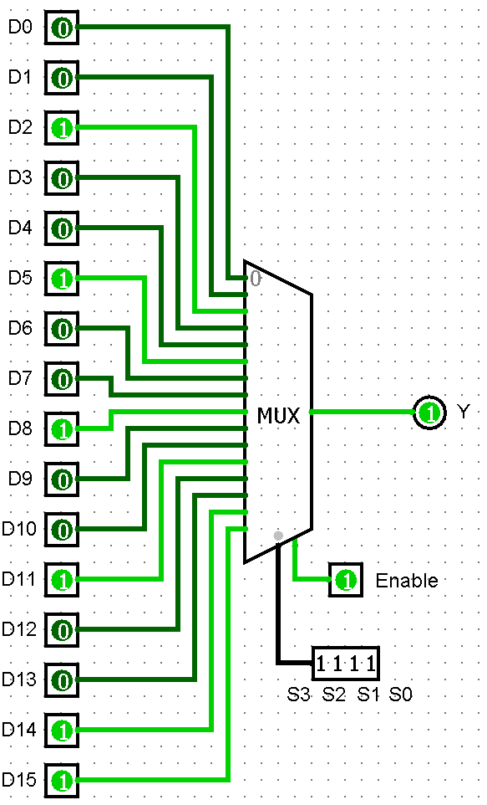 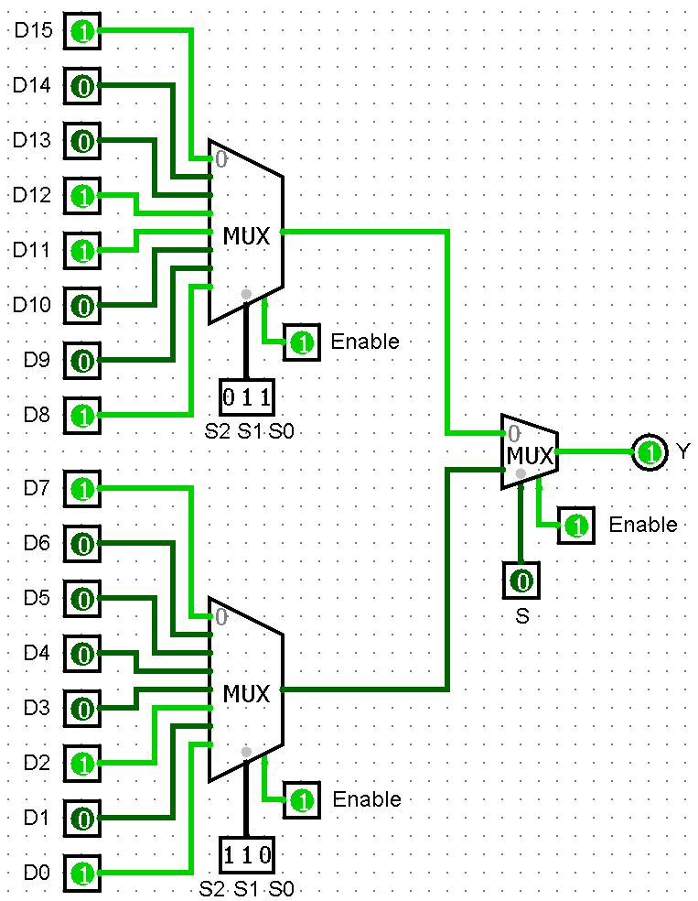

Above circuit diagrams are of 16:1 multiplexers using normal 16:1 MUX and two 8:1 MUXs with a 2:1 MUX respectively.

**Truth Table**:

|  |  |  |  |  |
| --- | --- | --- | --- | --- |
| **S3** | **S2** | **S1** | **S0** | **Y** |
| 0 | 0 | 0 | 0 | D0 |
| 0 | 0 | 0 | 1 | D1 |
| 0 | 0 | 1 | 0 | D2 |
| 0 | 0 | 1 | 1 | D3 |
| 0 | 1 | 0 | 0 | D4 |
| 0 | 1 | 0 | 1 | D5 |
| 0 | 1 | 1 | 0 | D6 |
| 0 | 1 | 1 | 1 | D7 |
| 1 | 0 | 0 | 0 | D8 |
| 1 | 0 | 0 | 1 | D9 |
| 1 | 0 | 1 | 0 | D10 |
| 1 | 0 | 1 | 1 | D11 |
| 1 | 1 | 0 | 0 | D12 |
| 1 | 1 | 0 | 1 | D13 |
| 1 | 1 | 1 | 0 | D14 |
| 1 | 1 | 1 | 1 | D15 |

**Demultiplexers**: De-Multiplexer is a combinational circuit that performs the reverse operation of a Multiplexer. It has single input, ‘n’ selection lines and maximum of 2n outputs. The input will be connected to one of these outputs based on the values of selection lines. Since there are ‘n’ selection lines, there will be 2n possible combinations of zeros and ones. So, each combination can select only one output. Demultiplexer is also called De-Mux.

**1:2 Demultiplexer**: A 1-to-2 demultiplexer consists of one input line, two output lines and one select line. The signal on the select line helps to switch the input to one of the two outputs. The figure below shows the block diagram of a 1-to-2 demultiplexer with additional enable input.

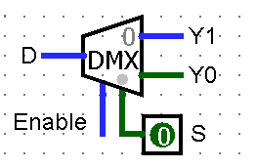

In the above figure, there are only two possible ways to connect the input to output lines, thus only one select signal is enough to do the demultiplexing operation. When the select input is low, then the input will be passed to Y0 and if the select input is high then the input will be passed to Y1.

**1:4 Demultiplexer**: A 1-to-4 demultiplexer has a single input (D), two selection lines (S1 and S0) and four outputs (Y0 to Y3). The input data goes to any one of the four outputs at a given time for a particular combination of select lines.

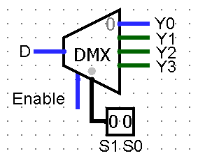

In the above figure, when both the select inputs 0 and 1are low, then the input will be passed to Y0, if the select input 0 is high and 1 is low then the input will be passed to Y1, if the select input 0 is low and 1 is high then the input will be passed to Y2 and if both the select inputs 0 and 1are high, then the input will be passed to Y3.

**Circuit Diagram**: Below is the 1:4 demultiplexer using normal 1:4 DEMUX

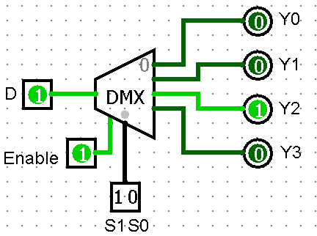

**Truth Table**:

|  |  |  |
| --- | --- | --- |
| **S1** | **S0** | **Y** |
| 0 | 0 | Y0 |
| 0 | 1 | Y1 |
| 1 | 0 | Y2 |
| 1 | 1 | Y3 |

**1:8 Demultiplexer**: A 1-to-8 demultiplexer has a single input (D), three selection lines (S2, S1 and S0) and eight outputs (Y0 to Y7). The input data goes to any one of the eight outputs at a given time for a particular combination of select lines.

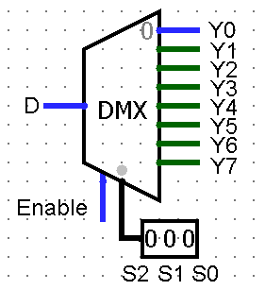

It is also called a 3-to-8 demultiplexer due to three select input lines. It distributes one input line to one of 8 output lines depending on the combination of select inputs.

**1:10 Demultiplexer**: A 1-to-10 demultiplexer has a single input (D), three selection lines (S2, S1 and S0) and ten outputs (Y0 to Y9). The input data goes to any one of the ten outputs at a given time for a particular combination of select lines.

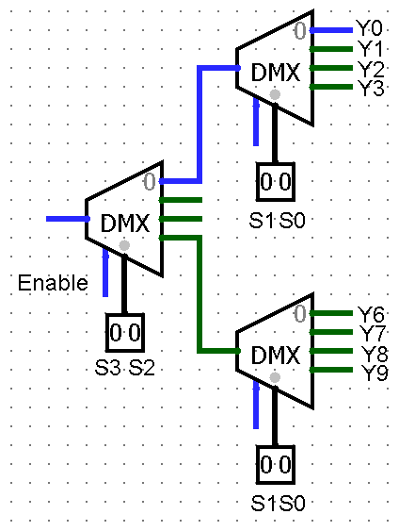

In the above figure, we have implemented 1-to-10 demultiplexer using three 1-to-4 demultiplexers. It distributes one input line to one of 10 output lines depending on the combination of select inputs.

**Circuit Diagram**:

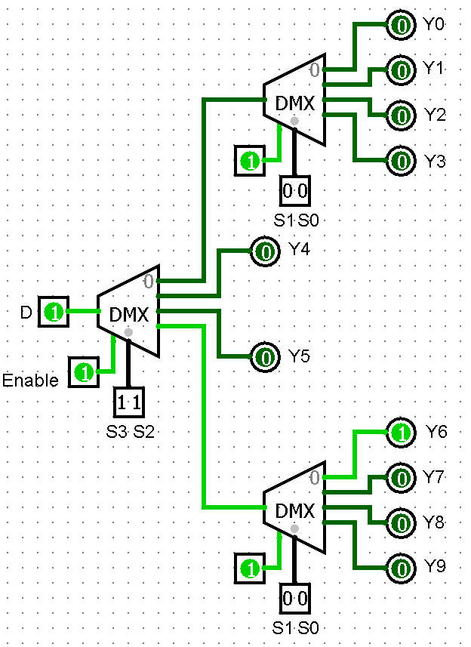

**Truth Table**:

|  |  |  |  |  |
| --- | --- | --- | --- | --- |
| **S3** | **S2** | **S1** | **S0** | **Y** |
| 0 | 0 | 0 | 0 | Y0 |
| 0 | 0 | 0 | 1 | Y1 |
| 0 | 0 | 1 | 0 | Y2 |
| 0 | 0 | 1 | 1 | Y3 |
| 0 | 1 | 0 | 0 | Y4 |
| 1 | 0 | 0 | 0 | Y5 |
| 1 | 1 | 0 | 0 | Y6 |
| 1 | 1 | 0 | 1 | Y7 |
| 1 | 1 | 1 | 0 | Y8 |
| 1 | 1 | 1 | 1 | Y9 |

**1:16 Demultiplexer**: A 1-to-16 demultiplexer has a single input (D), four selection lines (S3, S2, S1 and S0) and sixteen outputs (Y0 to Y15). The input data goes to any one of the sixteen outputs at a given time for a particular combination of select lines.

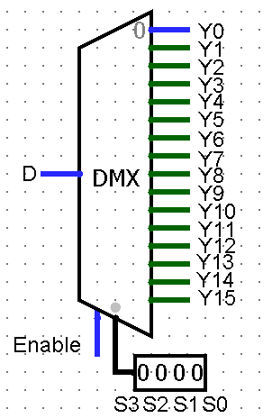

We can also implement 1-to-16 Demultiplexer using 1x8 De-Multiplexers and 1-to-2 Demultiplexer. We know that 1-to-8 Demultiplexer has a single input, three selection lines and eight outputs. Whereas, 1-to-16 Demultiplexer has single input, four selection lines and sixteen outputs.

**Selection of IC’s for Multiplexers and Demultiplexers**:

**IC’s for Multiplexers**:

|  |  |
| --- | --- |
| **IC** | **Multiplexer** |
| 74157 | 2:1 Multiplexer |
| 74153 | 4:1 Multiplexer |
| 74151 | 8:1 Multiplexer |
| 74150 | 16:1 Multiplexer |

**IC’s for Demultiplexers**:

|  |  |
| --- | --- |
| **IC** | **Demultiplexer** |
| 74139 | 4:1 Demultiplexer |
| 74138 | 8:1 Demultiplexer |
| 74154 | 16:1 Demultiplexer |

**Conclusion**: Thus, we have studied and understood the implementation of Multiplexers and Demultiplexers.